


TUGAS P8 - PEMROGRAMAN
Variabel & Fungsi String
NAMA
NRP
KELAS
MATA KULIAH
DOSEN
ASSISTEN DOSEN
TANGGAL PRATIKUM
:
:
:
:
:
:
:

Muhammad Aditya Rahmansyah

3226600122

ST.r Tekkom A

Pemrograman

Ir. Sigit Wasista, M.Kom.

Rofiulloh Mu'azin Al-insof, A.Md.

Kamis, 5 November 2026
Disusun Oleh :
PROGRAM STUDI SARJANA TERAPAN TEKNIK KOMPUTER
DEPARTEMEN TEKNIK INFORMATIKA DAN KOMPUTER
POLITEKNIK ELEKTRONIKA NEGERI SURABAYA
2026
Tugas 8.1

Code :
#include <stdio.h>
#include <string.h>

void strsisip(char *s, const char *sisip, int pos)
{
int n = strlen(s), m = strlen(sisip);
if (pos < 0) pos = 0;
if (pos > n) pos = n;
memmove(s + pos + m, s + pos, n - pos + 1);
memcpy(s + pos, sisip, m);
}

int main()
{
char teks[100] = "salah orang";
strsisip(teks, "se", 6);
printf("%s\n", teks);
return 0;
}

Output :
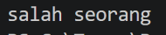

Tugas 8.2

Code :
#include <stdio.h>
#include <string.h>
#include <ctype.h>

int main()
{
char k[200], b[200];
int i, j = 0, n, palindrom = 1;

printf("Kalimat : ");
fgets(k, sizeof k, stdin);
k[strcspn(k, "\n")] = '\0';

for (i = 0; k[i]; i++)
if (isalnum((unsigned char)k[i]))
b[j++] = tolower((unsigned char)k[i]);
b[j] = '\0';
n = j;

for (i = 0; i < n / 2; i++)
if (b[i] != b[n - 1 - i]) { palindrom = 0; break; }

puts(palindrom ? "Termasuk PALINDROM" : "Bukan PALINDROM");
return 0;
}

Output :
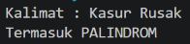
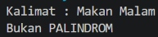

Tugas 8.3

Code :
#include <stdio.h>
#include <string.h>
#include <ctype.h>

int main()
{
char s[500];
int i, kecil = 0, besar = 0, angka = 0, baca = 0;

printf("Masukkan string: ");
fgets(s, sizeof s, stdin);
s[strcspn(s, "\n")] = '\0';

for (i = 0; s[i]; i++) {
unsigned char c = s[i];
if (islower(c)) kecil++;
else if (isupper(c)) besar++;
else if (isdigit(c)) angka++;
else if (ispunct(c)) baca++;
}
printf("Jumlah Huruf kecil = %d\n", kecil);
printf("Jumlah Huruf besar = %d\n", besar);
printf("Jumlah Angka Numerik = %d\n", angka);
printf("Jumlah Tanda Baca = %d\n", baca);
printf("Total Karakter = %d\n", kecil + besar + angka + baca);
return 0;
}
Output :
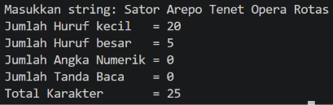

Tugas 8.4

Code :
#include <stdio.h>
#include <string.h>

int main()
{
const char *teks = "POLITEKNIK ELEKTRONIKA NEGERI SURABAYA";
int n = strlen(teks), i;

for (i = 1; i <= n; i++) {
printf("%*s%.*s\n", (n - i) / 2, "", i, teks);
}
return 0;
}

Output :
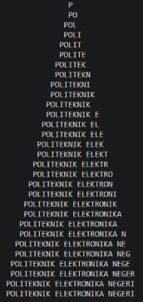

Tugas 8.5

Code :
#include <stdio.h>
#include <string.h>
#include <ctype.h>

int main()
{
char cek[52] = {'a','b','c','d','e','f','g','h','i','j','k','l','m',
'n','o','p','q','r','s','t','u','v','w','x','y','z',
'A','B','C','D','E','F','G','H','I','J','K','L','M',
'N','O','P','Q','R','S','T','U','V','W','X','Y','Z'};
int jmlh[52] = {0};
char s[300];
int i, j;

printf("Masukkan kalimat:\n");
fgets(s, sizeof s, stdin);
s[strcspn(s, "\n")] = '\0';

for (i = 0; s[i]; i++)
for (j = 0; j < 52; j++)
if (s[i] == cek[j]) { jmlh[j]++; break; }

printf("Jumlah huruf=%d\n", (int)strlen(s));
for (j = 0; j < 26; j++)
printf("%c = %d%s", cek[j], jmlh[j] + jmlh[j + 26], j < 25 ? ", " : "\n");
return 0;
}

Output :


